01
SALES PERFORMANCE DASHBOARD
Interactive Sales Analytics using Excel
PROJECT REPORT
PREPARED BY:
Maya Rai

ROLE:
Aspiring Data Analyst

Tools Used:
Microsoft Excel | Power Query | Power Pivot | DAX | VBA

Project Type:
Data Analytics Dashboard Project

Date:
22 June 2026

02
TABLE OF CONTENTS
No. | Topic | Page No.
1 | Project Overview | 3
2 | Project Objective | 3
3 | Dataset Description | 4
4 | Tools & Technologies Used | 4
5 | Data Cleaning & Transformation | 5
6 | Data Modeling | 6
7 | DAX Measures | 7
8 | Dashboard Design | 8
9 | Key Insights | 10
10 | VBA Automation | 10
11 | Conclusion | 11

03

PROJECT OVERVIEW
This project focuses on analyzing sales transaction data and building an interactive Sales Performance Dashboard using Microsoft Excel.

The project demonstrates an end-to-end data analytics workflow including data cleaning, transformation, data modeling, calculation creation, and visualization.

The raw sales data was processed using Power Query, analyzed using Power Pivot and DAX, and presented through an interactive dashboard with KPIs, charts, and slicers.

PROJECT OBJECTIVIES
The main objectives of this project are:
• Analyze sales performance and revenue trends
• Identify top-performing products and regions
• Understand customer and category performance
• Create interactive business reports
• Automate dashboard operations using VBA
• Convert raw data into meaningful business insights

PROJECT OVERVIEW AND
OBJECTIVIES

DATASET DISCRIPTION & TOOLS

04
Tool | Purpose
Microsoft Excel | Data analysis and dashboard creation
Power Query | Data cleaning and transformation
Power Pivot | Data modeling
DAX | Creating calculated measures
Pivot Tables | Data summarization
Pivot Charts | Data visualization
VBA | Dashboard automation

Column Name | Description
Order ID | Unique identifier for each order
Order Date | Date of transaction
Customer Name | Customer information
Region | Sales region
State | Customer location
Sales Person | Person responsible for sales
Product Category | Category of product
Product Name | Product details
Quantity | Number of units sold
Unit Price | Price per unit
Discount Percentage | Discount provided

Tools & Technologies Used
The dataset includes the following fields:
Data Cleaning & Transformation

The raw sales dataset was cleaned and transformed using Power Query to make the data suitable for analysis.
Steps Performed:
1. Data Type Correction
- Changed data types for:
  - Date columns
  - Numeric columns
  - Text columns
2. Data Quality Checks
Performed:
- Checked missing values
- Checked duplicate records
- Verified data consistency
3. Created Calculated Columns
Sales Amount
Formula:
Sales Amount = Unit Price × Quantity
This calculates the total value before applying discounts.

Discount Amount
Formula:
Discount Amount = Sales Amount × Discount Percentage
This calculates the total discount provided to customers.

Revenue
Formula:
Revenue = Sales Amount - Discount Amount
05
This represents the final revenue generated after discounts.

Data Modeling
After cleaning the data, a data model was created using Power Pivot.
A separate Calendar Table was created to perform time-based analysis.
Calendar Table Contains:
- Date
- Month
- Year
The relationship was created between:
Calendar [Date]
↓
Sales [Order Date]
This relationship helps in analyzing:
- Monthly sales trends
- Revenue performance
- Time-based comparisons
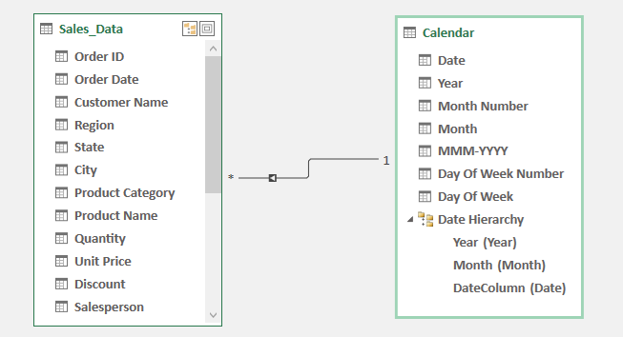
06
DAX Measures Created

The following measures were created using DAX:

Total Sales
Total Sales =
SUM (Sales [Sales Amount])

Total Revenue
Total Revenue =
SUM (Sales [Revenue])

Total Discount
Total Discount =
SUM (Sales [Discount Amount])

Total Quantity
Total Quantity =
SUM (Sales [Quantity])

Total Orders
Total Orders =
DISTINCTCOUNT (Sales [Order ID])

Average Order Value
Average Order Value =
DIVIDE ([Total Revenue] ,[Total Orders])
07

Dashboard Design
The final dashboard was created in Microsoft Excel to provide an interactive view of sales performance.
The dashboard helps users analyze business performance through KPIs, charts, and filters.

Key Performance Indicators (KPIs)
The dashboard includes:
- Total Sales
- Total Revenue
- Total Discount
- Total Quantity
- Total Orders
- Average Order Value

Interactive Visualizations
The dashboard contains:
1. Monthly Sales Trend
Used to analyze sales and revenue performance over time.
2. Regional Sales Analysis
Used to compare performance across different regions.
3. Category Performance
Shows which product categories contribute more revenue.
4. Top Product Analysis
08
Identifies best-performing products.

Filters / Slicers
Interactive slicers were added for:
- Product Category
- Region
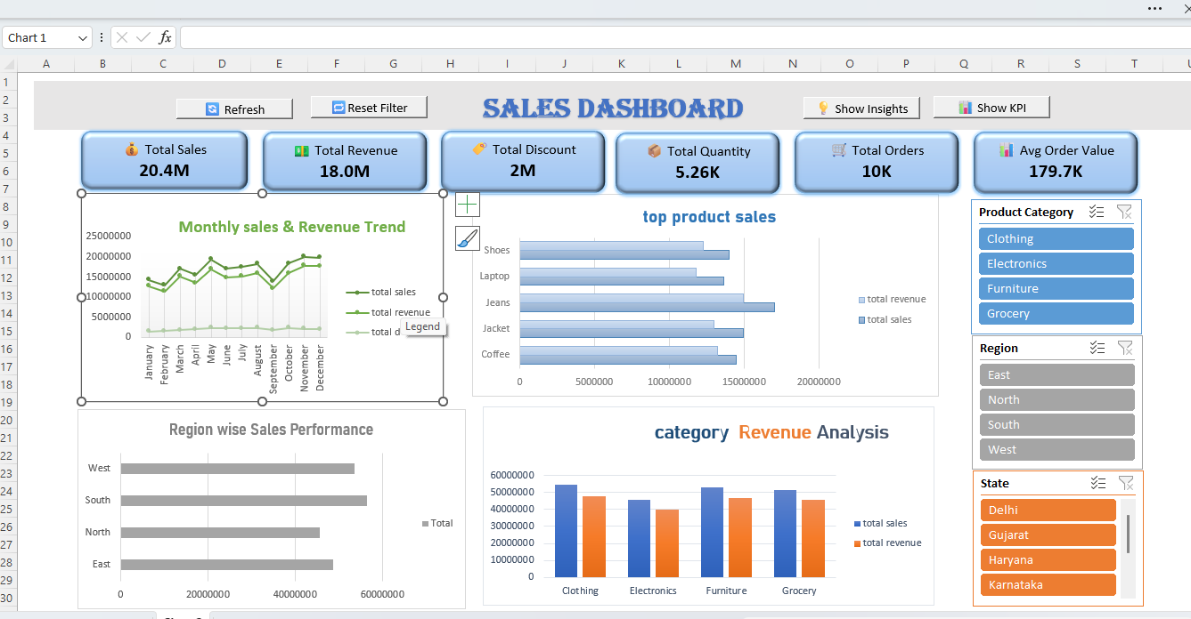
- State

09

Key Insights + VBA Automation + Conclusion

Key Insights
The dashboard analysis provided the following insights:
• Identified the highest-performing region based on sales.
• Analyzed monthly sales and revenue trends.
• Identified top-performing products and categories.
• Compared regional and category-wise performance.
• Evaluated the impact of discounts on revenue.

VBA Automation
VBA was used to improve dashboard usability and reduce manual work.
Automation features added:
1 Refresh Dashboard Button
- Updates all data and visuals automatically.
2 Reset Filter Button
- Clears all slicer selections.
3 Show KPI Button
- Displays KPI cards.
4 Show Insights Button
- Displays analysis insights.
10

Conclusion
This project demonstrates an end-to-end data analytics workflow using Microsoft Excel.
The project includes:
- Data cleaning using Power Query
- Data modeling using Power Pivot
- Business calculations using DAX
- Interactive dashboard creation
- Automation using VBA
The dashboard converts raw sales data into meaningful business insights and helps in data-driven decision making.

End of report

Project File:
Sales Performance Dashboard (.xlsm)
Report Format:
PDF
11
SSSSSABHJB

